Furnace Filter Information

Part of your responsibility in maintaining your property is changing the furnace filter. Below I will list multiple helpful resources so that you can easily change and maintain your property.

How to Video : <https://www.youtube.com/watch?v=YaGJiF_t1Fs&feature=youtu.be>

Where to Buy Filters : <https://www.lowes.com/search?searchTerm=furance+filter>

Helpful Articles: <https://www.fourseasonsheatingcooling.com/blog/springtime-for-furnaces/>

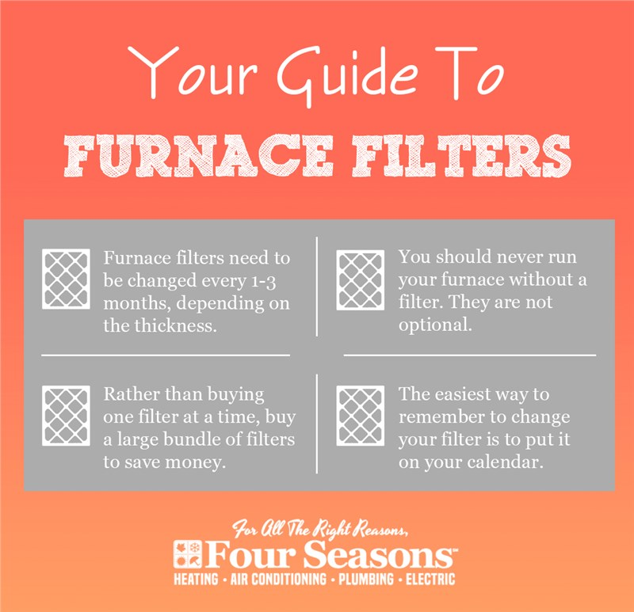<https://www.triad-propertymanagement.com/hvac-filter-program>